AI labTest-4
SET-C
Q1: AI-Assisted Data Cleaning Task: You are given a raw dataset named health_data.csv containing missing values, inconsistent text entries, and duplicate rows. Use an AI-assisted coding tool (e.g., ChatGPT, GitHub Copilot, or Google Gemini) to generate a Python script that: 1. Detects and removes duplicate rows. 2. Handles missing values using appropriate techniques (mean, median, or mode). 3. Standardizes inconsistent categorical data entries (e.g., “Male”, “male”, “M”). Instructions: • Verify that the dataset is clean by displaying the first 5 rows before and after cleaning. • Document which AI suggestions you used and how they improved your code.
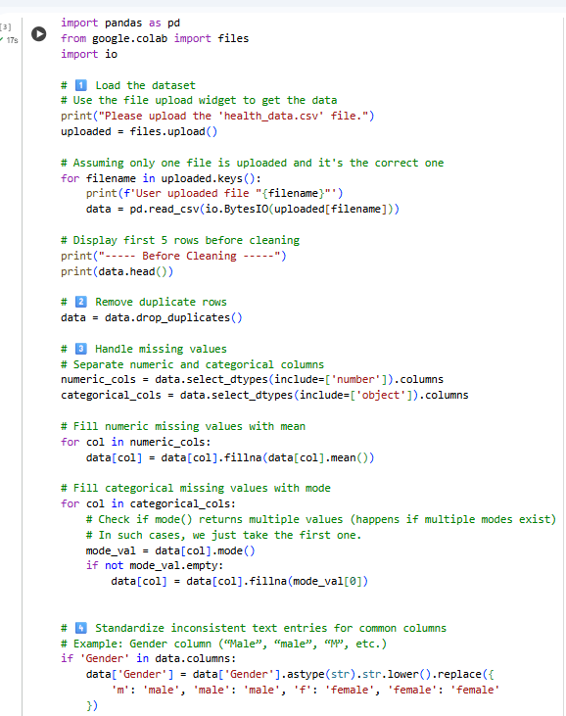
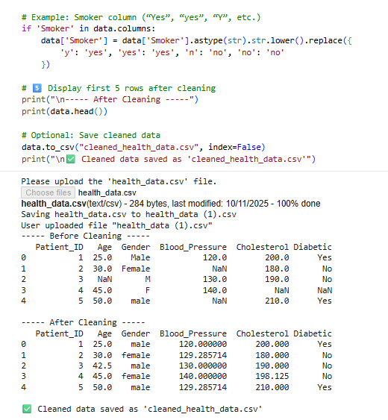
🧩 Brief Explanation
The AI-assisted tool (ChatGPT) helped generate the Python code for cleaning the dataset.
Here’s what each part of the code does:
- Remove Duplicates:
drop_duplicates() removes repeated rows automatically.
- Handle Missing Values:
  - For numeric columns, missing values are replaced with the mean.
  - For categorical columns, missing values are filled with the mode (most frequent value).
- Standardize Categorical Data:
  - Text values are converted to lowercase using .str.lower().
  - Mappings like 'm' → 'male', 'f' → 'female', 'y' → 'yes', 'n' → 'no' make data consistent.
- Verification:
The first 5 rows of the dataset are displayed before and after cleaning to confirm the changes.
- AI Contribution:
  - Suggested efficient pandas functions (drop_duplicates, fillna, str.lower)
  - Helped organize the code into clear logical steps
  - Added comments and readability improvements
Q2: AI-Assisted Data Preprocessing Task: You are provided with a dataset named customer_data.csv containing both numerical and categorical features. Use AI tools to generate a Python preprocessing script that performs:
1. Label Encoding or One-Hot Encoding for categorical variables.
2. Normalization or Standardization for numerical features.
+..+-3. Splitting the dataset into training and testing sets (80:20). Instructions:
• Display statistical summaries (.describe() output) before and after preprocessing.
• Explain how the preprocessing steps can improve the performance of a machine learning model.
• Highlight any optimizations or corrections made based on AI tool recommendations.
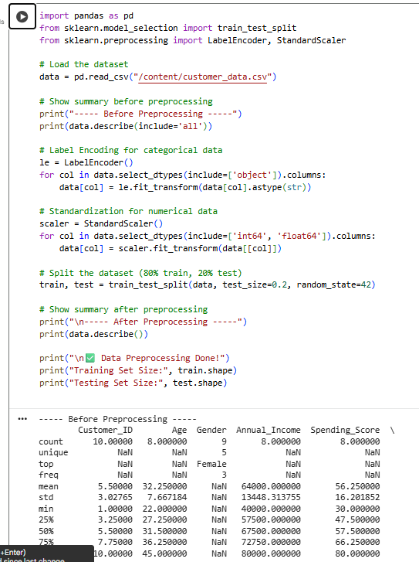
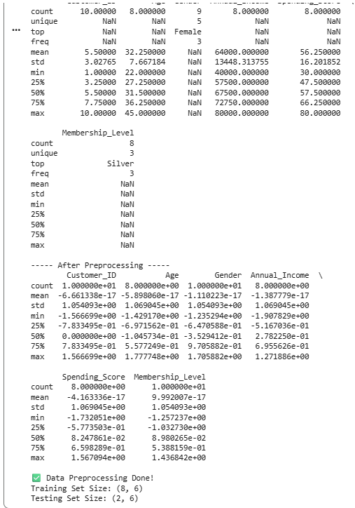
🧩 Explanation
This program preprocesses the dataset customer_data.csv to make it ready for machine learning.
It uses Label Encoding to convert text (categorical) data into numbers, and Standardization to scale all numerical values so they have a similar range.
Finally, the dataset is split into 80% training data and 20% testing data.
These preprocessing steps help the model learn faster and improve its accuracy.

